**Exercise** – 4

**Aim: Linux File Systems**

1. The File Hierarchy Standard (FHS) is a specification that defines the file system hierarchy of a

Linux OS. Illustrate about the use of all directories under the “\” as given in the figure.

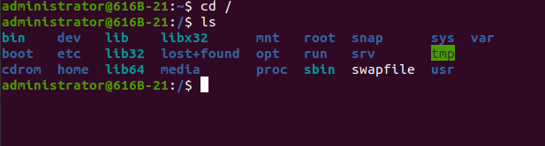

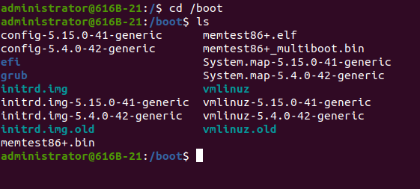

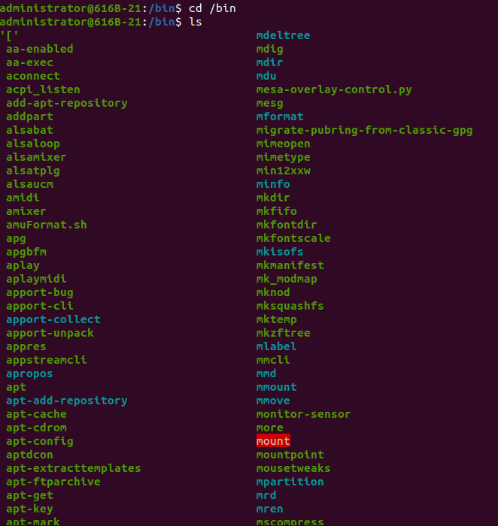

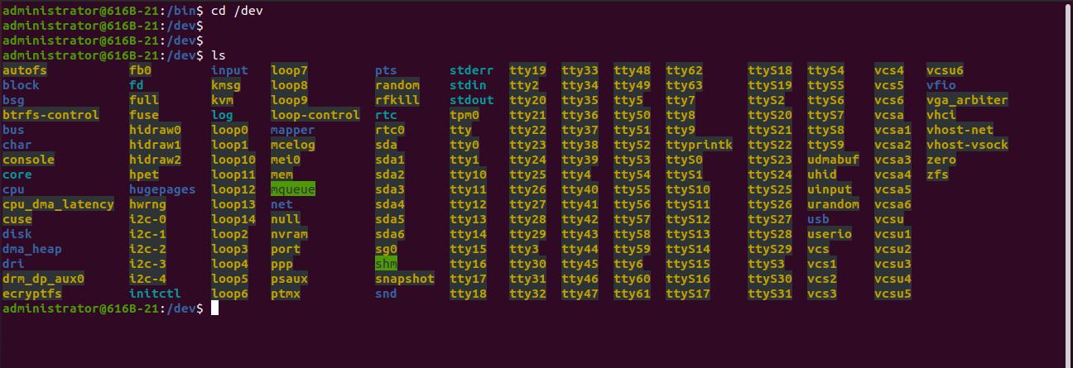

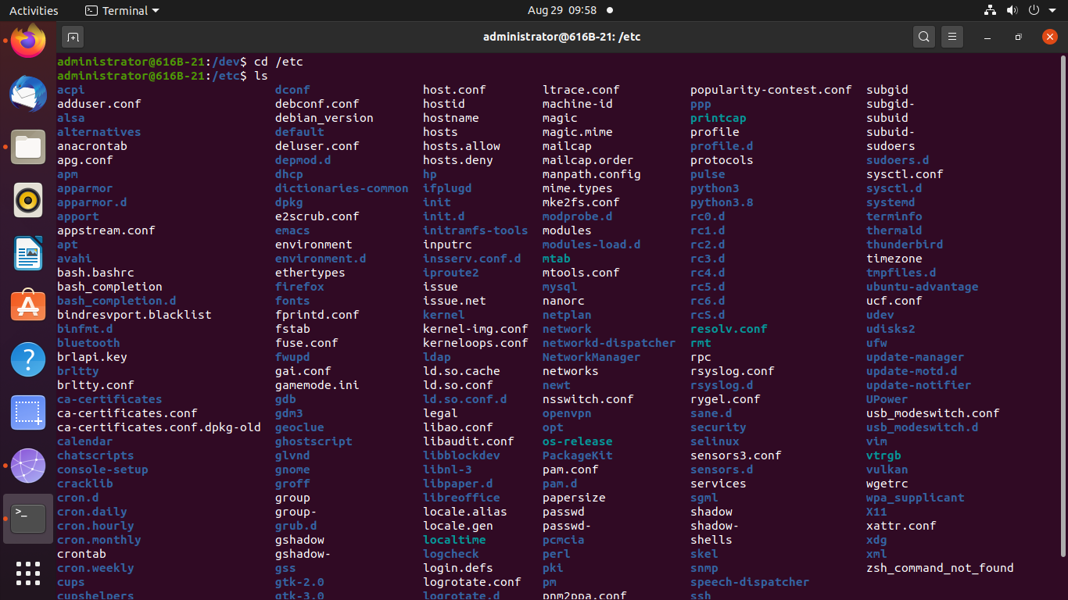

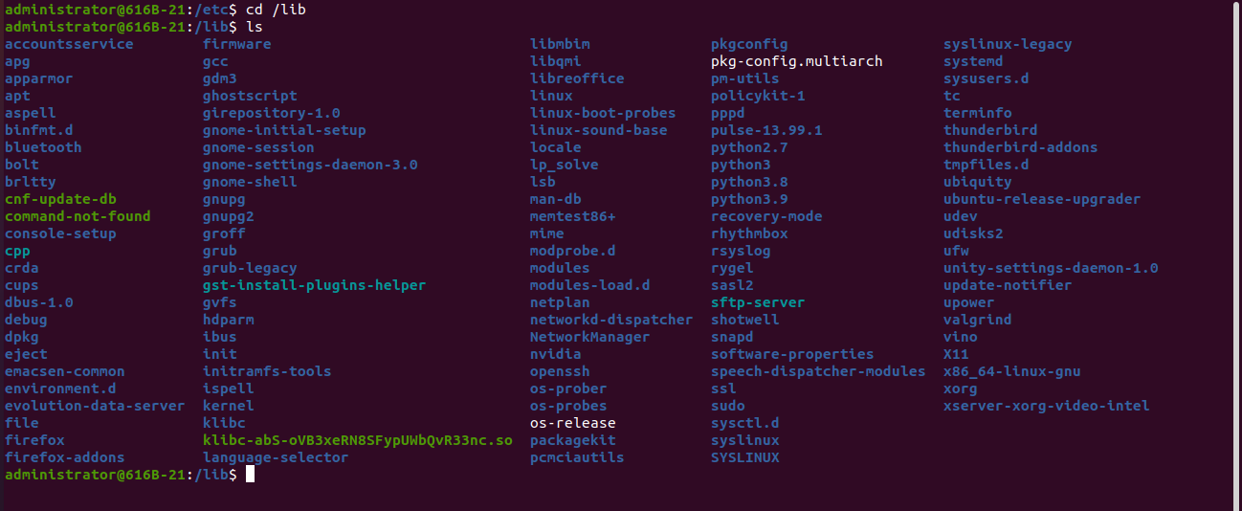

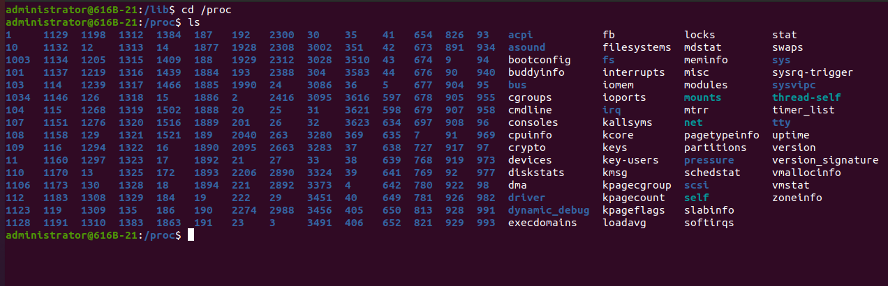

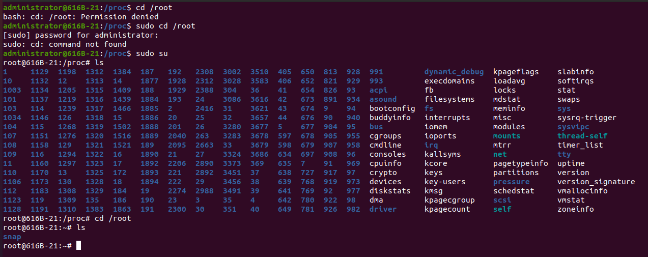

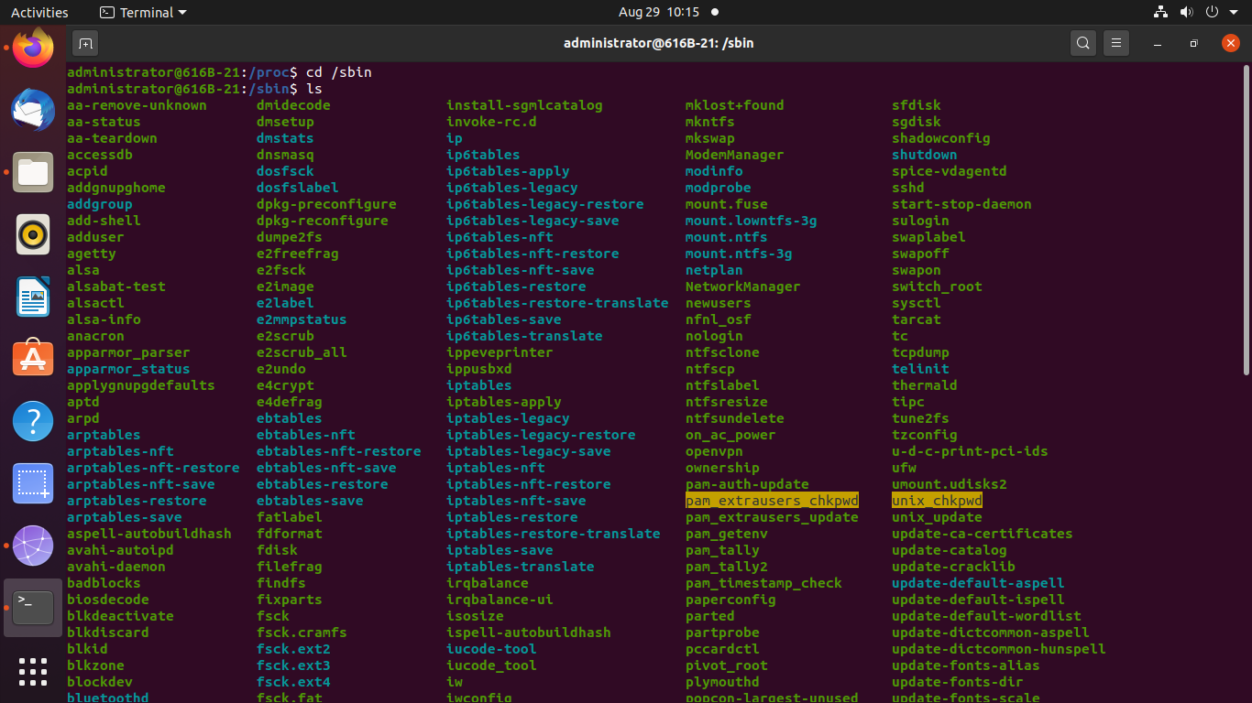

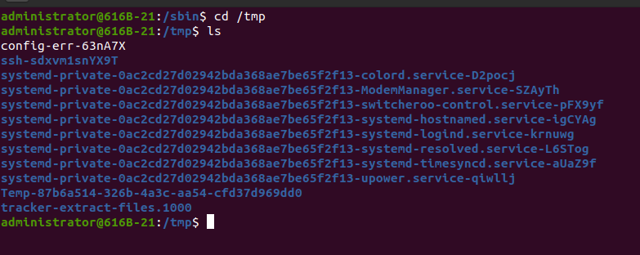

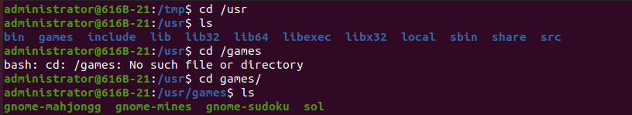

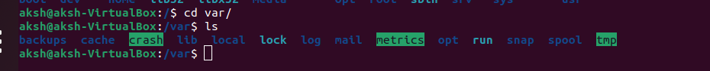

2. List out files in your directory.

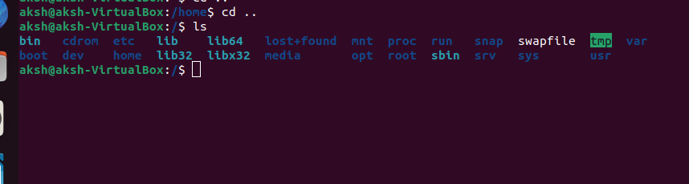

3. Create a hard link to one of the file exist in your directory. (ln [original file] [link name])



4. Apply ls –l and check whether the link is created or not. Also check the size of linked file

created.

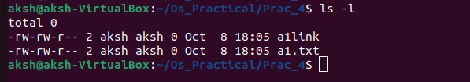

5. 5Update the existing file.

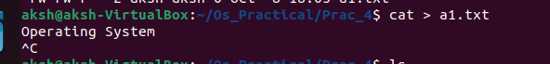

6. Apply ls –l and check the size of linked file created.

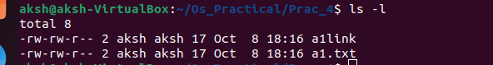

7. Check the content of both the files and write your observation.

The content of both file have same.

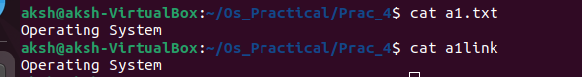

8. Delete the existing file on which you have created the link.



9. Apply ls –l and observer the output.

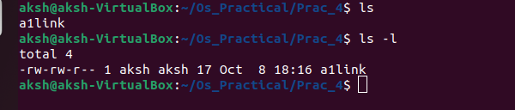

10. Perform exercise 2 to 9 for creation of soft link and write your observation. (ln –s [original file]

[link name])

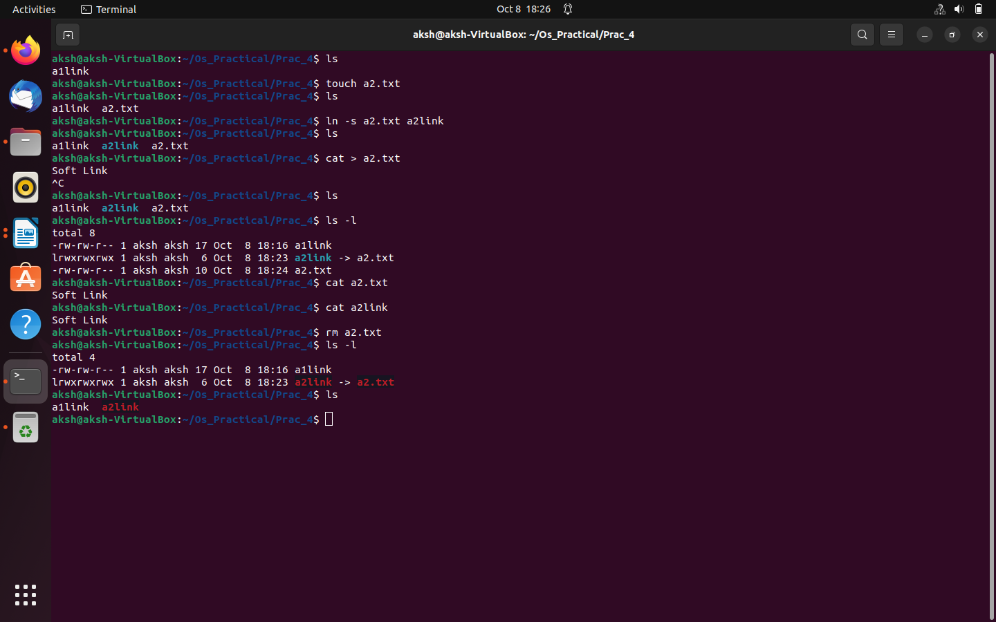

11. Write difference between hard link and soft link.

The major difference between a hard link and soft link is that **hard link is the direct reference to the file whereas soft link is the reference by name which means it points to a file by file name**.

12. Apply ls –l /dev/sda1

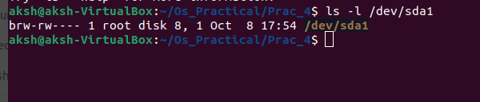

13. To get an overview of local and remote file system devices and the amount of free

space available, run the df command

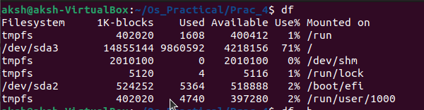

14. Apply df –h and see the difference in the output

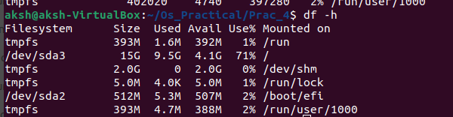

15. For more detailed information about space used by a certain directory tree, use

the du command. Apply du /home/ID_No

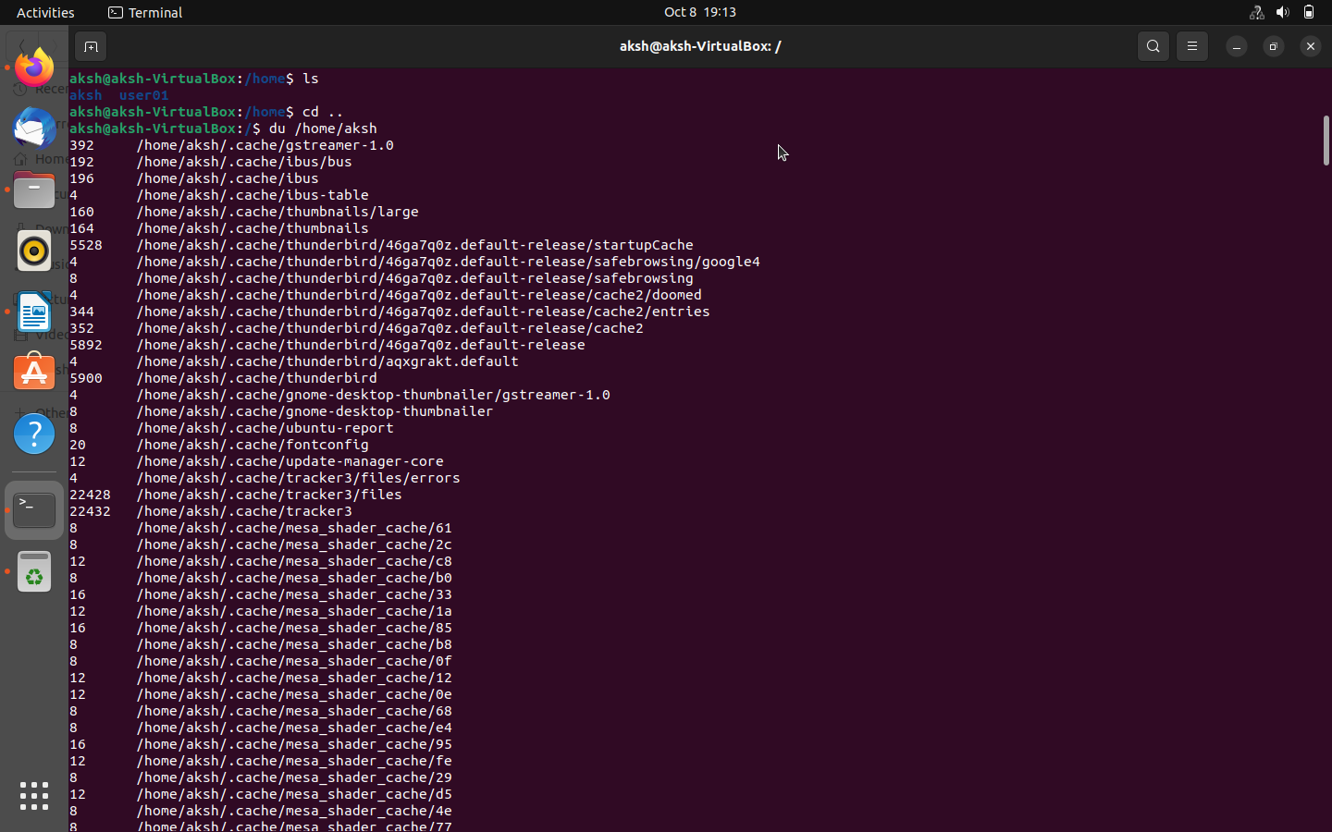

16. Apply du –h /home/ID_No and see the difference in the output

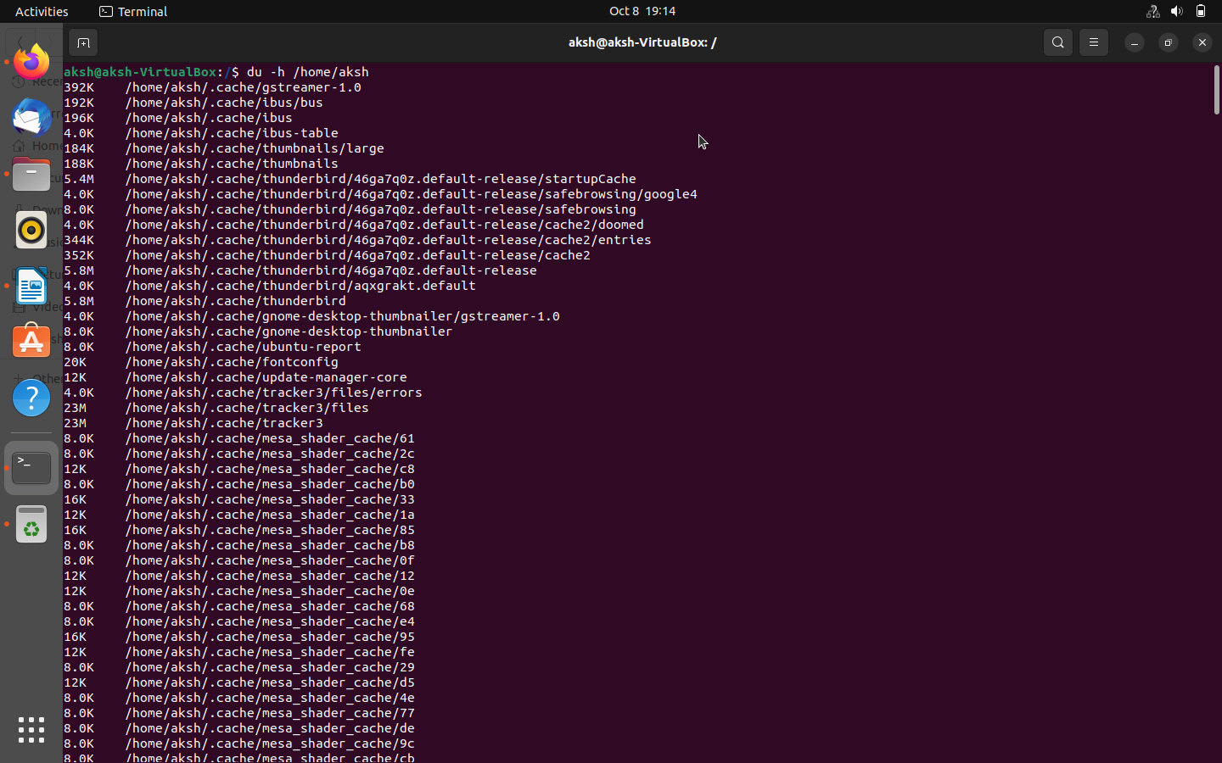

17. Use the lsblk command to list the details of a specified block device or all the

available devices

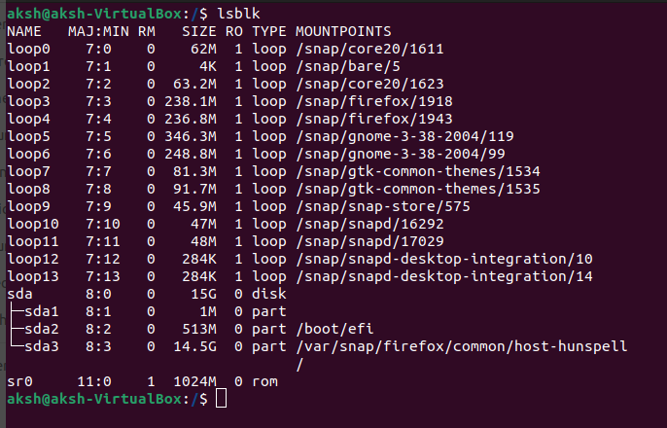

18. Apply locate passwd and see the output.

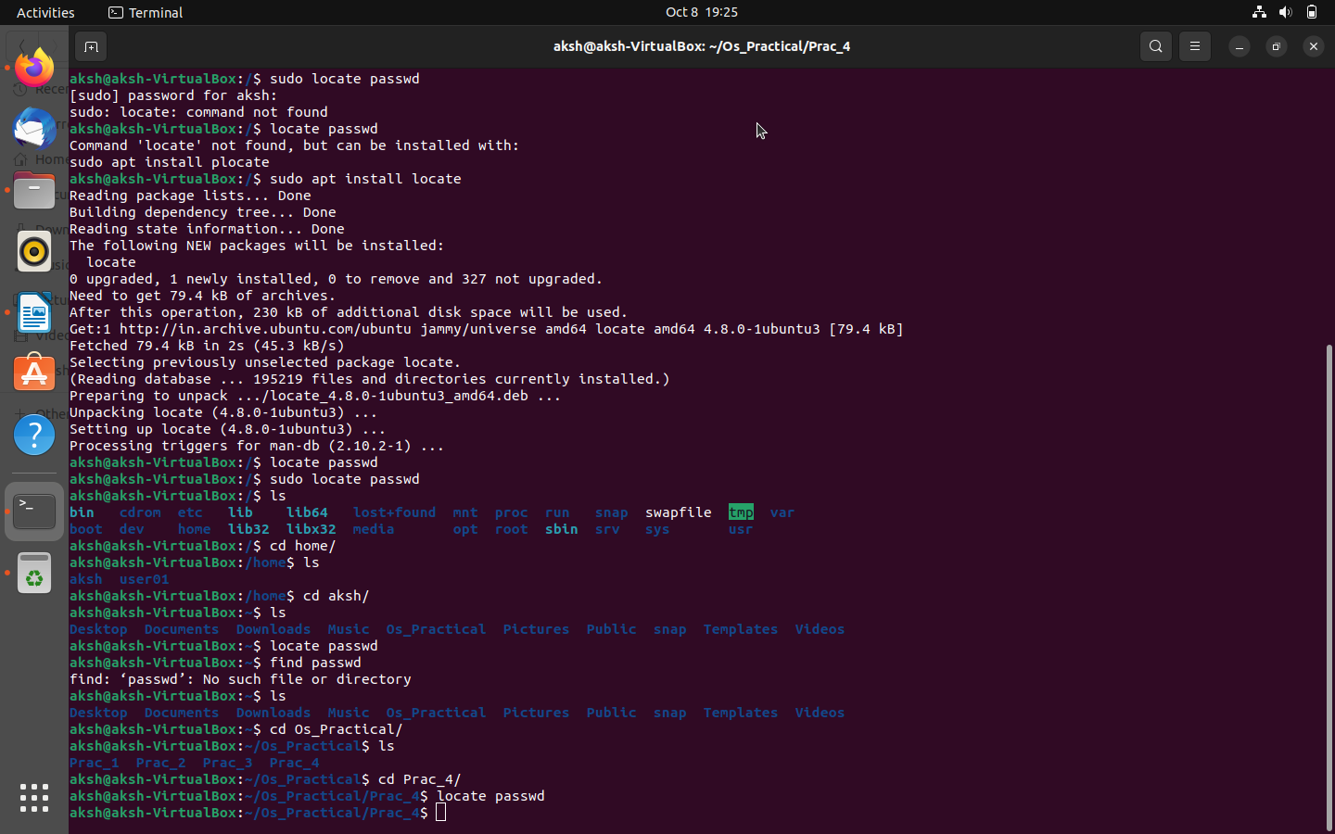

19. To search for files by file name, use the -name FILENAME option. With this

option, find returns the path to files matching FILENAME exactly. Search for files

named sshd_config starting from the / directory. (find / -name sshd_config)

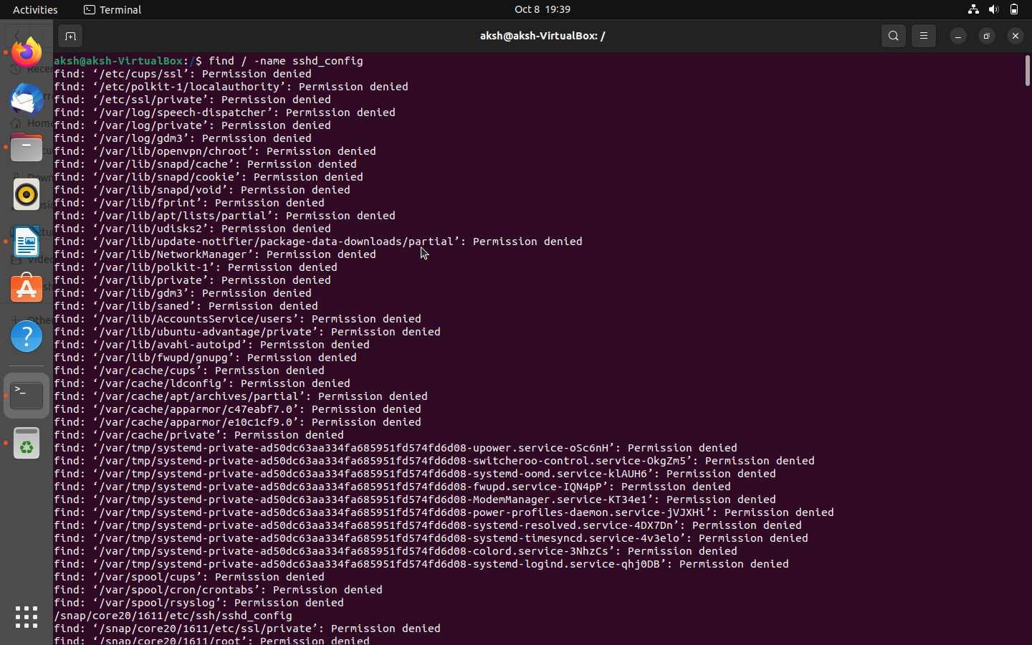

20. search for files starting in the / directory that end in .txt.

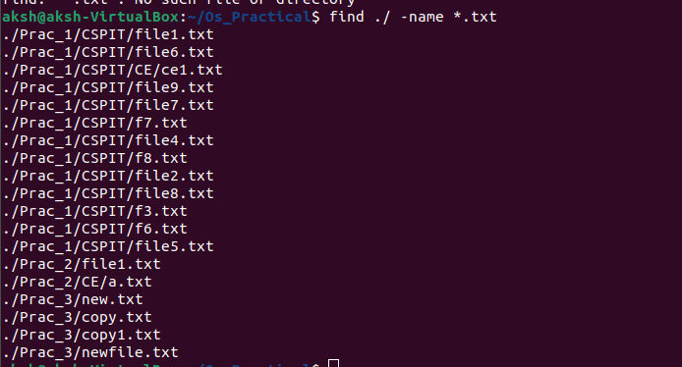

21. search for files in the /etc/ directory that contain the word, “pass”.

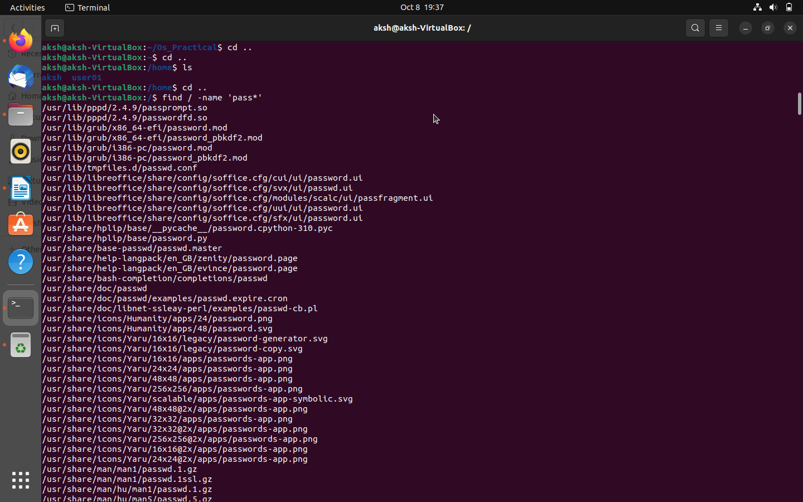

22. Search for files owned by user in the /home/ID_No directory.

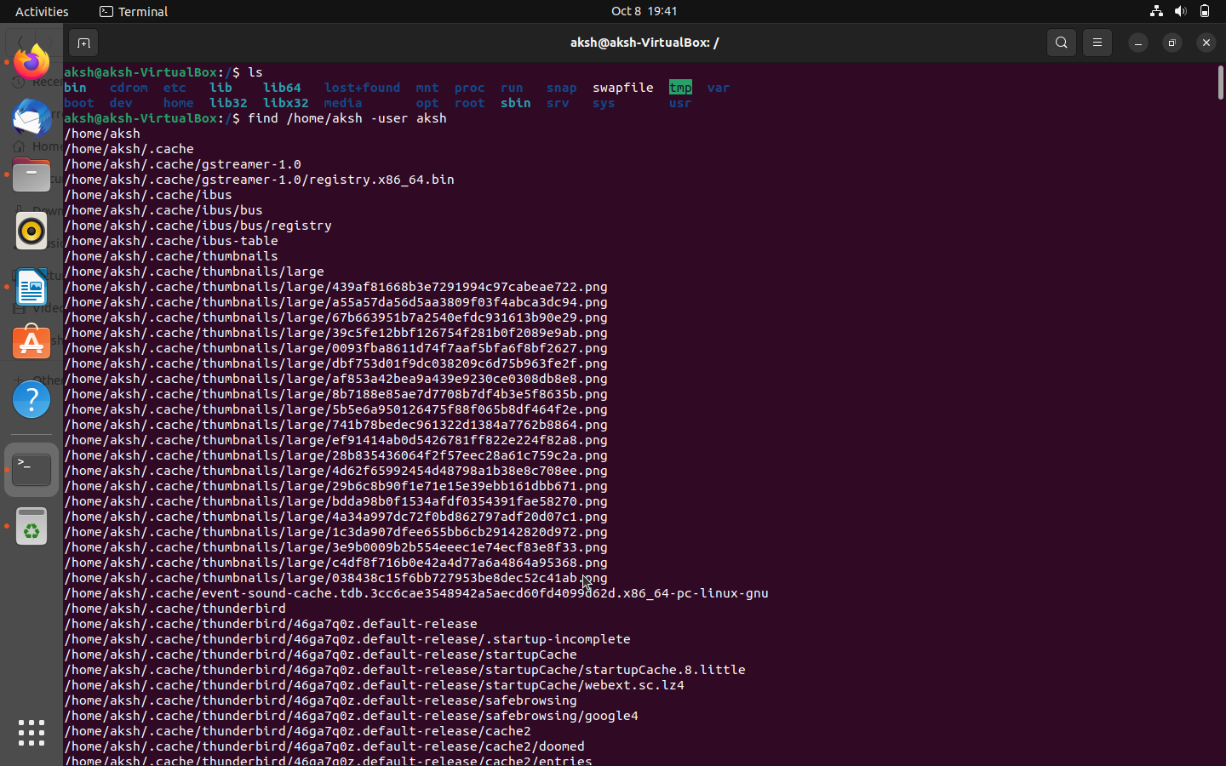

23. Search for files owned by the group user in the /home/ID_No.

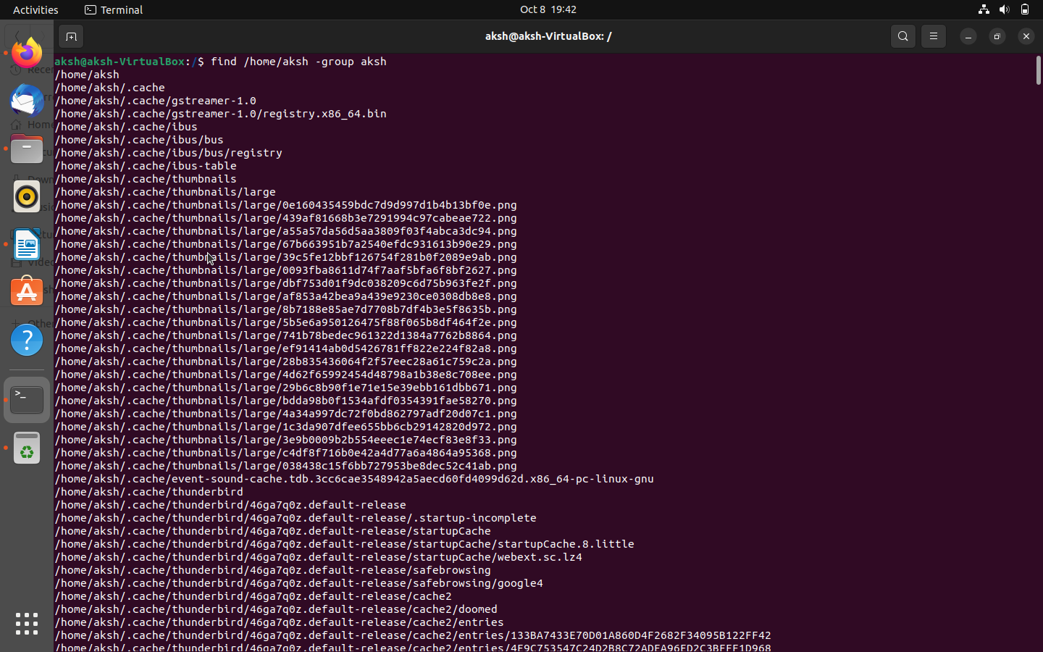

**Mount and unmount USB drive**

24. Apply df -h to see the partitions.

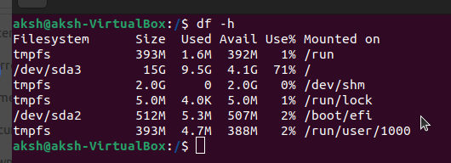

25. Unmount your USB drive by locating its path

**Command:- umount ./media/20CE020/USBSTORAGE**

**Explanation: It will unmount our usb from system.**

26. Again, apply df -h and check your USB if it is accessible or not.

**Command: df -h**

27. Mount your USB drive into directory. (Create one directory and inside that apply mount

drive directory name command)

**sudo mount ./ /media/20CE020/USBSTORAGE**

**Explanation: It mount usb in our System**

28. Again, apply df -h command and check whether it is mounted or not.

**Command: df -h**